**Crowd Canvass**

**Software Design Document**

**05/07/2021**

**COSC 4920-102**

**Crowd Canvass**

**Shayne Burns**

**Ramzi Carter**

**Wylie Frydrychowicz**

**Max Rothweiler**

**Hannibal Santiago**

**Links to Relevant Resources**

1. **Online Project Notebook**

<https://github.com/WyFryMU/crowd-canvass>

1. **Business Plan**

[https://github.com/WyFryMU/crowd-](https://github.com/WyFryMU/crowd-canvass/blob/master/Documents/Crowd%20Canvass%20Business%20Plan.docx) canvass/blob/master/Documents/Crowd%20Canvass%20Business%20Plan.docx

1. **Project Management Plan**
   1. **Project Management Tool**

<https://trello.com/b/IAMrTxNv/crowdcanvass>

* 1. **Source Code Repository**

<https://github.com/WyFryMU/crowd-canvass/>

1. **Test Plan**

<https://github.com/WyFryMU/crowd-canvass/blob/master/Documents/CrowdCanvass-ProjectManagement%20(includes%20test%20plan).pdf>

1. **Sprint Presentation Links**

<https://github.com/WyFryMU/crowd-canvass/tree/master/Documents/SprintUpdates>

**Design Overview**

Crowd Canvass is a crowd sourced canvassing web application. By crowd sourcing the canvassing process, Crowd Canvass can reach smaller organizations and communities that would normally be left out by larger canvassing applications. It allows for two different types of users: 1. organizers who are looking to create events, and 2. volunteers who are looking to join canvass campaigns and community focused events. As an organizer, this entity can create both community events as well as canvassing events. They can also attach a survey form for their events allowing users to take the survey and use it while canvassing. These surveys also come with analytics based on the responses through google forms. As a volunteer, this entity is unable to create events, but has the ability to sign up for events on our interactive map. The interactive map shows events within an individual’s area as well as a list of events which can be used to sign up. Volunteers can also see the list of events which they have signed up for, as well as remove themselves from events they have previously joined. Both volunteers and organizers also have quality of life account management forms. In the future, there a hope to implement additional features such as a payment option, so organizers can pay volunteers for their work on their events.

**Design Components**

Crowd Canvass is a web application that people can use via any device that connects to the internet. Upon the loading of the home page, the user has the option of choosing to create events or viewing events within their area, all which prompt the user to create an account or sign into their existing account. The purpose of this is to ensure that the data for each user is generated properly and consistent with storing the data to a specific user as well.

When a user creates an account, they get two options for account type: organizer and volunteer. An organizer can create events, as well as sign up for events, while a volunteer can only view and sign up for events.

After the user has signed into their account, the home page displays the purpose for the web application: creating canvass or service events intended to improve the existing community through work. There are buttons once again, for account users to create events, if they are organizers, as well as a button that will link the user to another page where they will see a map generated with the events nearby, as well a list of the events that were generated on the map. The map produced is generated with the Google Maps API, and it is connected to the database that stores all the events created. Events can be signed up either using the list or the map, via a button called, “sign up”.

When a user creates a canvass event specifically, we have steps telling the individual to how to create a google form, and how to link the google form into the canvass event generation through an input line that asks for the user to insert the link to the google form. Steps are also provided on how the organizer can view the analytics of the survey form they created.

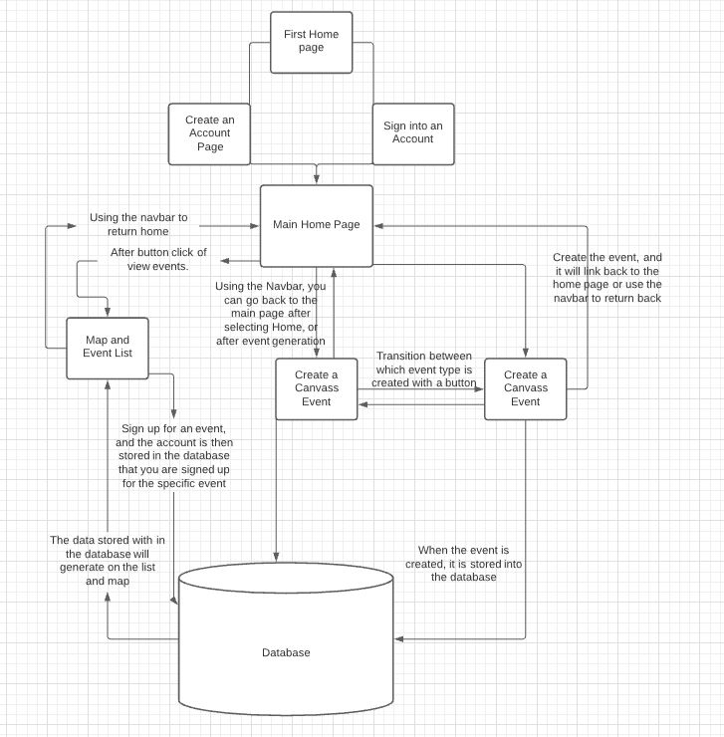

The front end, or the interface that the users see and interact with on their screen, is built using HTML, a coding language specifically designed for building websites. The styling of the web pages is created with Bootstrap, a specific styling method used to manipulate the objects on the screen, and it makes it easier for the objects to place without object overlap. Each coding language can be learned via w3schools. The back end, or data management and storage, is built into firebase, a free resource that people can use to host the website pages. This resource is helpful for storing input data into the database which is within firebase as well.

**High Level Software Flow**

On a high level, users are the initiators of the software. Users will start up the web application by accessing the webpage. From accessing the homepage, the user will either sign up or login. If the user does not have an account, they will sign up and enter the required credentials. If the password and re-entered password do not match, the software will prompt the user to check these fields to ensure they match. Once all credentials are properly entered, the software will take the user to the account main page after login. In the case of a user having an account already, the user will select login and enter their credentials. If the credentials do not match what is stored in the database, the user will be notified that these credentials cannot be found. Additionally, if the user does not enter a valid formatted email, they will be notified that their entered email is badly formatted. The diagram below depicts the high-level software flow chart that covers the materials mentioned in this paragraph.

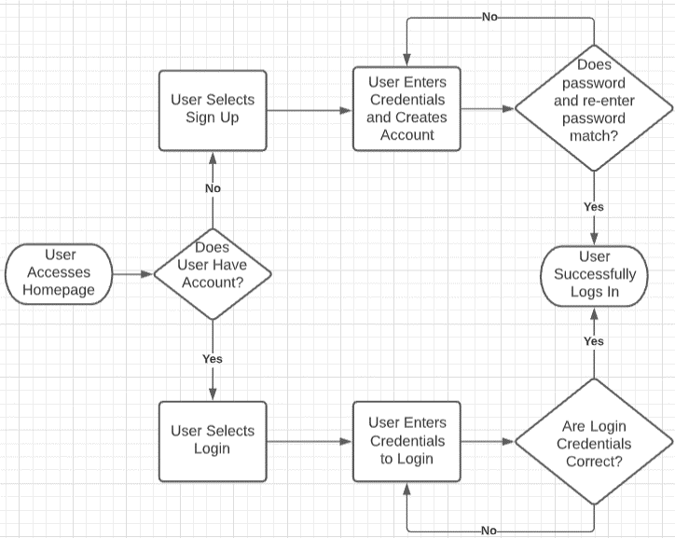

Volunteers and organizations initiate the software with certain nuances. In regard to volunteers, once successfully logged in, this entity will select View Events Within Your Area to see nearby events. They can then interact with our google maps API to view events geographically. Volunteers can then select events to sign up for. These events can be viewed by volunteers on the View Events Signed Up for Page, where they can then access event surveys. Lastly, volunteers can manage their account through the Manage Account page. On this page, volunteers will enter credentials to change password. However, if the new password and re-entered new password do not match, they will not be able to change their password until these fields are the same string. The diagram below depicts the high-level software flow chart that covers the materials mentioned in this paragraph.

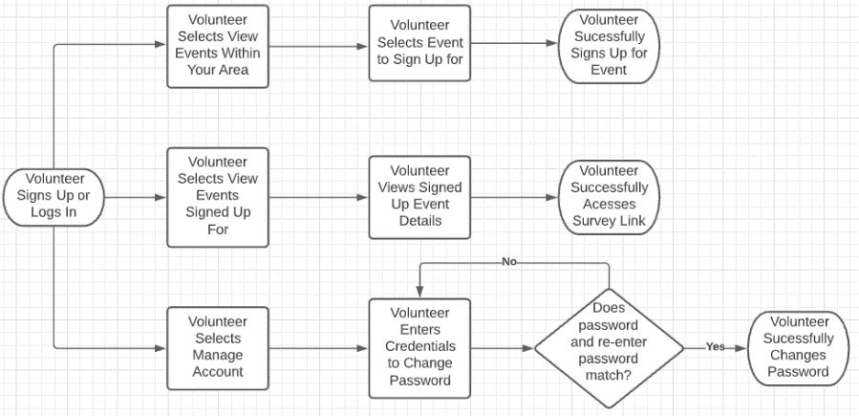

Moving onto how organizations initiate the software, once successfully logged in, organizations can choose to either create a canvass or community service event. When creating either event, credentials must be entered as these details such as event address will be used to populate the event geographically through the google maps API. Organizations can manage their account in the same way as the previously mentioned volunteer entity. The diagram below depicts the high-level software flow chart that covers the materials mentioned in this paragraph.

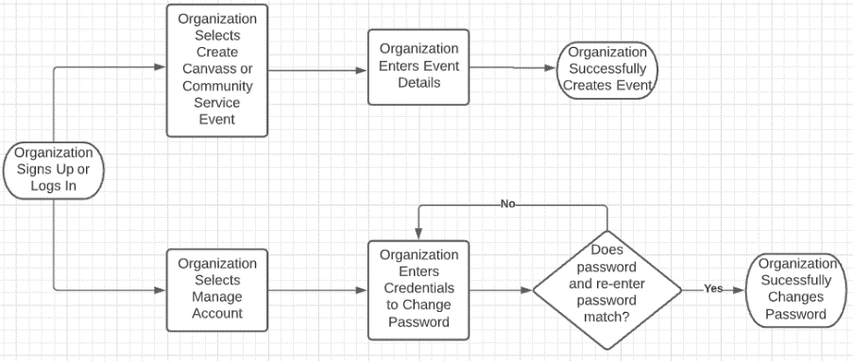

**Additional Design Considerations & SDD**

1. **Database Design**

This image above shows the 4 tables that are in the Firestore NoSql database. The main relationship between the tables is the one shown. That being that the User’s document ID is their UserID when it is referenced in the other 3 tables. Each user has One DocID which can be used Many times in the other tables.

1. **User Interface Design**

The user will first land on our home page. Then the user will either Login or Sign Up. If the user signs up, then they log in. After logging in, the user reaches our main page. From the main page, the user will have access to managing their account, viewing events in their area, and viewing events the user signed up for. If the user has an organizer role, the user can also create canvass or service events and pay volunteers. If the user has a volunteer role, they can collect payments.

1. **Input/Output Specifications**

To create events, users will fill out forms, then that form will be saved as an event.

To create an account, the user will enter some basic information and then an account gets created.

To change password, the user will enter in a new password then click a button to change password.

To view events signed up for, the user will go to the events page and the page will take the userID and show events they signed up for.

To view all events, the user goes to the map and the page will automatically populate the map with the events.

To log in, the user will enter an email and password and then get access to the main page after signing in, if they have an account.

1. **Feature/Module Documentation**

|  |  |  |  |  |  |
| --- | --- | --- | --- | --- | --- |
| **Module / Component** | **Purpose** | **Link to resources** | **Direct link to requirement in Trello/online notebook** | **Direct link in repo** | **Direct link to test cases** |
| Bootstrap | UI/UX | <https://getbootstrap.com/docs/5.0/getting-started/introduction/> | <https://trello.com/c/Lx69oW8E/27-a-cleaner-more-user-friendly-ui-especially-for-mobile-devices> | <https://github.com/WyFryMU/crowd-canvass/blob/master/public/index.html> | N/A |
| Google Maps API | Using google maps to show events | <https://developers.google.com/maps/documentation/javascript/overview> | <https://trello.com/c/rHKJ8gjz/51-maps-is-used-to-populate-events-local-to-the-user> | <https://github.com/WyFryMU/crowd-canvass/blob/master/public/firebasemap.js> | N/A |
| Cloud Firestore | NoSql Database for storing information | <https://firebase.google.com/docs/firestore> | <https://trello.com/c/bBFf3HXg/66-develop-a-database> | <https://github.com/WyFryMU/crowd-canvass/blob/master/public/createAccount.js> | N/A |
| Firebase Auth | Creating user accounts using email/pass | <https://firebase.google.com/docs/auth> | <https://trello.com/c/RaH0BMIb/54-login-is-used-to-create-account-or-access-account-information> | <https://github.com/WyFryMU/crowd-canvass/blob/master/public/accountMainPageAfterSignIn.js> | N/A |

**Go Live & Hand Off Plan**

Currently, our web application is functional and is hosted live on firebase. While our web application does function as intended, we believe there are more features and refinements that should be added before going fully live. These include but are not limited to security enhancements, Android/iOS apps, PayPal functionality, geolocation tracking, and in-app surveys and analytics. Once these features are successfully integrated, the web application will be much closer to fully going live. In terms of the hand off plan, we will be providing our stakeholder with all code and supporting documentation. All materials will be available to the stakeholder on GitHub. Additionally, we have had a final meeting with our stakeholder to walk them through the documentation and code organization scheme. The stakeholder has our contact information in case they have future questions.